Bose-Einstein Condensation
Student: Miaoyin Wang (miaoyinwang@gmail.com)
Instructor: Elbio Dagotto
Class: Solid State II, 2010, Spring semester
Institution: Department of Physics,
University of Tennessee, Knoxville
1. Bosons and Bose-Einstein distribution
A way to distinguish from one object to another is to exchange the two objects and observe if the system has been changed or not. If the system remains the same, we can determine that the two objects cannot be distinguished. Daily life objects can always be distinguished from each other. However, the identical quantum particles like electrons are indistinguishable, and they are separated into two kinds: fermions and bosons. Fermions have half integer spin and follow the Pauli exclusion principle: any of the two fermions (of same kind) cannot be in the same state. Bosons have integer spin and do not follow the Pauli exclusion principle, which means two or more bosons can be in the same state.
In statistical mechanics, the principle of indifference told us that we can get the particle distribution by counting the number of available quantum states using combinatorics. For identical quantum particles, if we have N identical bose particles in M available quantum states, then there are
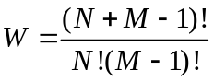
available ways that the particles can be distributed [1].
Now apply this combinatoric rule to the thermodynamics of an ideal gas of N boson particles occupying a volume V. For the ideal gas, the density of the state per unit volume is
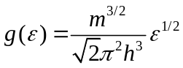
and the entropy of the gas is S=k_{B} ln W, where k_{B} is Boltzmann’s constant and W is the available microstates of a given total energy E. To calculate W, suppose there are N_{S} particles between energy E and E + dE, and there are M_{S} quantum states at this energy. Then sum over all energy gives the total number of available microstates:
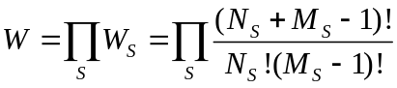
Using the Lagrange multipliers
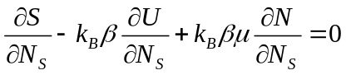
we can finally get (here I skip some of the tedious steps):
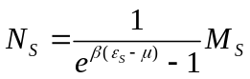
Since the average number of particles occupying any single quantum state is N_{S}/M_{S}, and therefore the average occupation number of any given single particle sates of energy 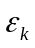 is given by the Bose-Einstein distribution:
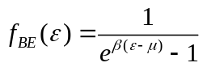

2. Bose-Einstein Condensation (BEC)

After getting the Bose-Einstein distribution, we can derive the Bose-Einstein condensation from it. The first property we may notice about the distribution is that the term 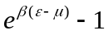 may smaller than zero, which makes the distribution negative. To avoid this, we require 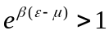 for all energy, i.e.
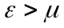
Suppose the lowest energy of the system is 0, then we have
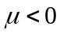
From statistic mechanics we know that  is determined by
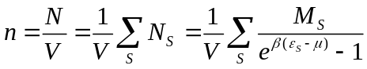
where 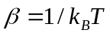. When temperature decreases, should increase (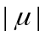 decrease) to satisfy the above function.
Assume that there is a certain temperature T_{c} where 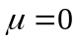. Then substitute it into above function and replace the sum by integral, we can derive the critical temperature T_{c} by solving
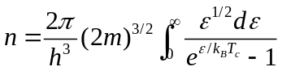
and
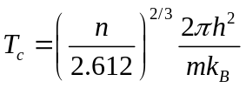
So what will happen when T < T_{c} ? Since (hit the upper limit and cannot be higher) for all the temperature below T_{c}, we can observe that n is no longer a constant, but decrease with the temperature is lowered. This result is contrary to 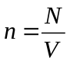.
To solve this problem, adding an extra term n₀(T) in to the formula
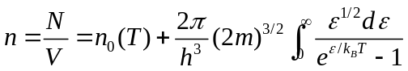
where n₀(T) is the particle density at 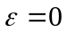.
It should be notified that above T_{c}, the N₀(T) should have the magnitude of ~ 0, since particle number on every energy level should be a fraction of total number. Now N₀(T) = V*n₀(T) is a finite number, which indicates the fact that, below T_{c} , huge amount of bosons are condensed on lowest energy level, and the number of the particle on is comparable to the total number N. This phenomenon is called “Bose-Einstein Condensation” [2].
N₀(T) can then be calculated:
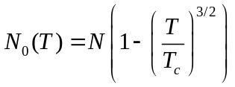
As can be seen above, at T=0, all bosons are condensed on ground state.

3. Discovery of Bose-Einstein Condensation in Experiments

3.1 Temperature-density Phase Diagram and Experimental Difficulty of BEC
To achieve BEC in experiment, it is needed to cool the system to a temperature below T_{c}. Observe the critical temperature again:
There are two quantities that we can control in an experiment: the temperature T and the atomic density n. As can be seen in the above formula, T_{c} is larger with larger n, which means either by increasing the density n or decreasing the temperature T will help to achieve BEC.
To describe these relations, a very helpful picture is the temperature-density phase diagram, which shows the state of material in temperature-density space. A typical BEC phase diagram is shown in Figure 1.

Figure 1. Generic phase-diagram common to all atoms. The dotted line shows boundary between non-BEC and BEC. The solid line shows the boundary between allowed and forbidden regions of the temperature-density space. Note that at low and intermediate densities, BEC exists only in the thermodynamically forbidden regime. [3]
Figure 1 shows that at low density and high temperature, there is a vapor phase, and at high density there are various condensed phases. But the intermediate densities are thermodynamically forbidden, except at very high temperatures. Unfortunately, the BEC region of the n-T plane falls in the forbidden region. If we try to higher the density, atoms or molecules would form a crystalline lattice, which will of course prevent BEC from happening. The black square in the diagram is the liquid helium, which luckily remains liquid below BEC [3].
However, the fact that BEC state falls in the thermodynamically forbidden region does not mean it is impossible to achieve. Consider the time scales for different sorts of equilibrium. There are two time scales for equilibrium in this case: the BEC equilibrium time and the chemical equilibrium time. BEC equilibrium is caused by the two-body collision, while the chemical equilibrium is caused by the three-body collision. At very low density, the two body collision is dominant (which is reasonable since the possibility is lower for atoms to approach each other), which will make the time scale of BEC equilibrium much shorter than the chemical equilibrium. So a stable BEC state can occur before gas atoms find their way to the stable solid-state condition.
Through above discussion, it may conclude that the following things should be considered in a BEC experiment:
- A dilute gas with low density is needed.
- An ultra-low temperature need to be achieved since the density is low.
- A very quick ‘camera’ (detector) is needed to measure the BEC gas right after the BEC is formed.
To realize 1 and 2 involves cooling and pumping techniques, and to realize 3 involves measurement via laser pulse. The experimental details will be introduced later.

3.2 First Observation of Bose-Einstein Condensation in a Dilute Atomic Vapor
3.2.1 Introduction
The first "pure" Bose–Einstein condensate was created by Eric Cornell, Carl Wieman, and co-workers at JILA on June 5, 1995. They did this by cooling a dilute vapor consisting of approximately two thousand rubidium-87 atoms to below 170 nK using a combination of laser cooling [4,5].
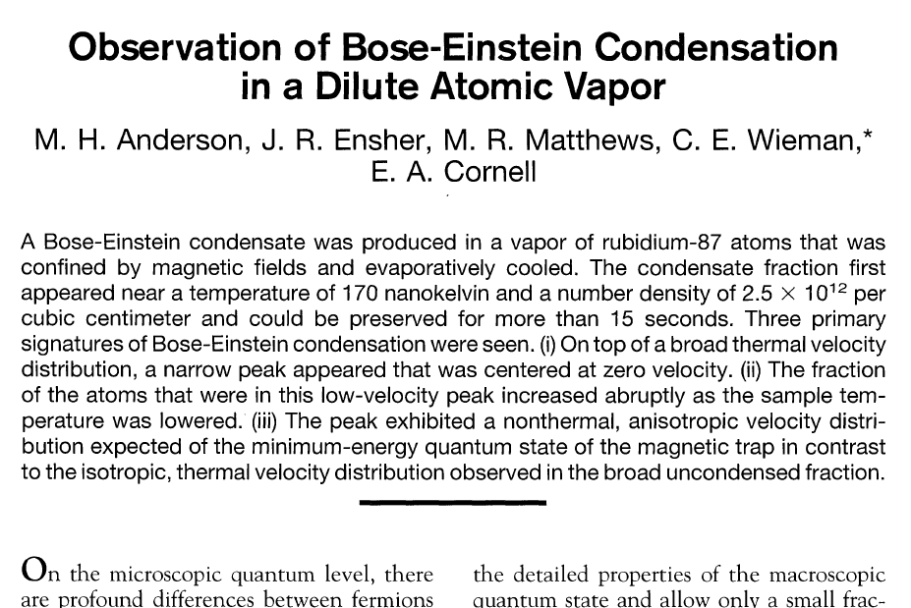

3.2.2 Choice of Material
In the paper, the reason to use alkali atoms is listed as followed:
i) The heavy alkali atoms are readily cooled and trapped with laser light, and the elastic scattering cross sections are very large, which facilitates evaporative cooling.
ii) By exciting the easily accessible resonance lines, one can use light scattering to sensitively characterize the density and energy of a cloud of such atoms as a function of both position and time. This technique provides significantly more detailed information about the sample than is possible from any other macroscopic quantum system.
iii) As in hydrogen, the atom-atom interactions are weak [the S- wave scattering length a_{o} is about 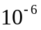 cm, whereas at the required densities the inter-particle spacing (x) is about 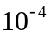 cm] and well understood.
iv) These interactions can be varied in a controlled manner through the choice of spin state, density, atomic and isotopic species, and the application of external fields. The primary experimental challenge to evaporatively cooling an alkali vapor to BEC has been the achievement of sufficiently high densities in the magnetic trap.

3.2.3 Trapping and Cooling Method
Figure 2 shows the apparatus of the experiment and how the atoms is trapped and cooled. Six laser beams intersect in a glass cell, creating a magneto-optical trap (MOT). The cell is 2.5 cm square by 12 cm long, and the beams are 1.5 cm in diameter. The coils generating the fixed quadrupole and rotating transverse components of the TOP trap magnetic fields are shown in green and blue, respectively. The glass cell hangs down from a steel chamber containing a vacuum pump and rubidium source. Also not shown are coils for injecting the rf magnetic field for evaporation and the additional laser beams for imaging and optically pumping the trapped atom sample.

Figure 2. Schematic of the apparatus. [5]
Finally, about 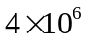atoms with a temperature of about 90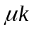 was in the trap. It was then evaporatively cooled for 70 s, during which time both the radio frequency (rf) and the magnitude of the rotating field were ramped down. At the end of cooling, the sample was allowed to equilibrate for 2 s and then expanded the cloud to measure the distribution. After a 60-ms expansion, the spatial distribution of the cloud was determined from the absorption of a 20-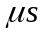, circularly polarized laser pulse resonant.

3.2.4 Measured Data

Figure 3. A 3-D velocity distribution data of a gas of rubidium atoms. This is a famous figure of BEC. Figure 4 provide a clearer 2-D version. [4]
Velocity-distribution was measured under different temperature. Figure 4 shows the measured data and figure 3 is the famous 3-D version of it. The anisotropy of the peak on the right figure is important and is clearer in 2-D figure (figure 4).
The experimentalists did a 2D time-of-flight measurement of velocity distribution. At each point of the image, the optical density observed is propotional to the column density of atoms at the corresponding part of the expanded cloud. So the recorded image is the initial velocity distribution projected on to the plane of the image. The peak is not infinitely narrow because of the Heisenberg uncertainty principle. Since the atoms are trapped in a certain space region, the velocity should be broadened due to the uncertainty principle. Notice that the left image is isotropic, while the right image is anisotropic. The anisotropic is caused by the anisotropic shape of the space region, which is another good proof for the BEC.

Figure 4. False-color images display the velocity distribution of the cloud (A) just before the appearance of the condensate, (B) just after the appearance of the condensate, and (C) after further evaporation has left a sample of nearly pure condensate. The circular pattern of the non-condensate fraction (mostly yellow and green) is an indication that the velocity distribution is isotropic, consistent with thermal equilibrium. The condensate fraction (mostly blue and white) is elliptical, indicating that it is a highly non-thermal distribution. The elliptical pattern is in fact an image of a single, macroscopically occupied quantum wave function. The field of view of each image is 200
by 270
. The observed horizontal width of the condensate is broadened by the experimental resolution. (?) [5]

Figure 5. Peak intensity at the center of the sample as a function of the final depth of the evaporative cut. [5]
180nk
1600nk
Figure 5 shows the peak intensity at the center of the sample as a function of the final depth of the evaporative cut 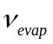. We can see that at 4.23 MHz the BEC state start to appear, and goes to maximum at 4.1 MHz. Below 4.1 MHz, the evaporative ‘rf scalpel’ begins to cut into the condensate itself. The temperature and have a complicated but monotonic relation that at 4.7 MHz, T = 1.6, and at 4.25 MHz, T=180 nk.

- Other Experiment on Bose-Einstein Condensation

Superfluid state of Helium-4 at 2.17K is discovered in 1938 [1], which is the first partial BEC of the liquid observed. However, the interaction between the atoms are relatively strong, and there’s only about 8% of the atoms accumulate in ground state. So superfluid is not a “pure” BEC.

Fermions can be cooled to extremely low temperature to exhibit Bose-Einstein condensation. To realize this, fermions must “pair up” to for compound particles (like molecules or Cooper pairs) that are bosons. The first molecular Bose-Einstein condensates were created in November, 2003 [6], and the first cooper pair BEC were soon created right after that.

Magnons was found to have a BEC transmission temperature at room temperature [7]. This is achieved by pumping the magnons into the system and form a high density n.

5. References

[1] Superconductivity, Superfluids and Condensates, J.F.Annett, ISBN 7-03-023624-1
[2] Thermodynamics and Statistical Mechanics, Zhicheng Wang, ISBN 7-04-011574-3
[3] Levi, Barbara Goss (2001). "Cornell, Ketterle, and Wieman Share Nobel Prize for Bose–Einstein Condensates". Search & Discovery. Physics Today online. http://www.physicstoday.org/pt/vol-54/iss-12/p14.html.
[4] Bose-Einstein Condensation, Wikipedia,
http://en.wikipedia.org/wiki/Bose%E2%80%93Einstein_condensate#cite_note-nobel-4
[5] M.H. Anderson, J.R. Ensher, M.R. Matthews, C.E. Wieman, and E.A. Cornell (1995). "Observation of Bose–Einstein Condensation in a Dilute Atomic Vapor". Science 269 (5221): 198–201.
[6 ] S. Jochim, M. Bartenstein, A. Altmeyer, G. Hendl, S. Riedl, C. Chin, J. Hecker Denschlag, and R. Grimm (2003). "Bose–Einstein Condensation of Molecules". Science 302 (5653): 2101–2103
[7] Demokritov, S.O.; Demidov, VE; Dzyapko, O; Melkov, GA; Serga, AA; Hillebrands, B; Slavin, AN (2006). "Bose–Einstein condensation of quasi-equilibrium magnons at room temperature under pumping". Nature 443 (7110): 430–433

