NNeutron Scattering Facilities All Around the World
Yuen Yiu
University of Tennessee, Department of Physics and Astronomy

Abstract
We will briefly introduce a number of neutron facilities that are currently running in the western world. We will also talk about the related commissioned ESS project in Sweden. We will provide a more or less extensive list of the remaining, unmentioned neutron scattering facilities in the world.
List of Neutron Scattering Facilities

United States:
Spallation Neutron Source (SNS) @ Oak Ridge National Laboratory
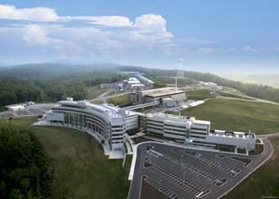
Running since: 2006
Neutron source: Spallation
Number of available instruments: 12
Number of instruments currently under construction: 7
Closest major city: Knoxville, TN (25 mi)
SNS provides the most intense pulsed neutron beams in the world. SNS is a user facility that welcomes researchers from all over the world. A planned upgrade to heavy water (deuterium oxide) as central cooling water will improve the neutron output. SNS is managed by Oak Ridge National Laboratory for the DOE, Office of Science.
The Central Laboratory & Office Building (CLO) accommodates presently 300 to 400 outside research visitors a year. A separate building connected to the CLO houses the Center for Nanophase Materials Sciences. The SNS facility is designed so that the second target facility building can be constructed to double the overall experimental capacity.
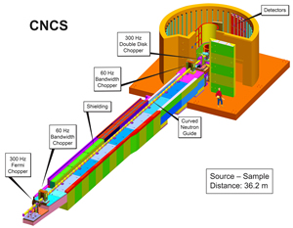
A schematic for the Cold Neutron Chopper Spectrometer (CNCS) at SNS
SNS has the capacity to accommodate up to 24 neutron beam instruments.
On August 11, 2007, the SNS became the most powerful neutron source in the world, surpassing the ISIS neutron source at Rutherford Appleton Laboratory. On September 18, 2009, SNS achieved a new world record when 1 megawatt of proton beam power was delivered.
At the end of 2007 SNS was recorded in the Guinness book of records as the most powerful pulsed spallation neutron source in the world.
----------------------------------------------------
High Flux Isotope Reactor (HFIR) @ Oak Ridge National Laboratory
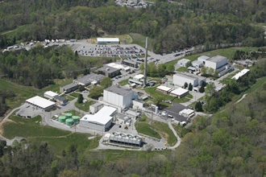
Running since: 1966
Neutron source: Nuclear Fission
Number of available instruments: 8
Number of instruments currently under construction: 3
Closest major city: Knoxville, TN (25 mi)
Operating at 85 MW, HFIR is the highest flux reactor-based source of neutrons for condensed matter research in the United States, and it provides one of the highest steady-state neutron fluxes of any research reactor in the world. The intense neutron flux, constant power density, and constant-length fuel cycles are used by more than 200 researchers each year for neutron scattering research into the fundamental properties of condensed matter.
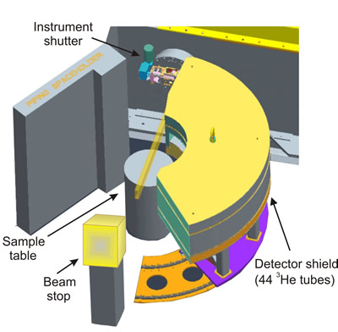
A schematic for the Neutron Powder Spectrometer (HB-2A) at HFIR
HFIR is projected to continue operating until at least 2040.
----------------------------------------------------

Los Alamos Neutron Science Center(LANSCE) @ Los Alamos National Laboratory
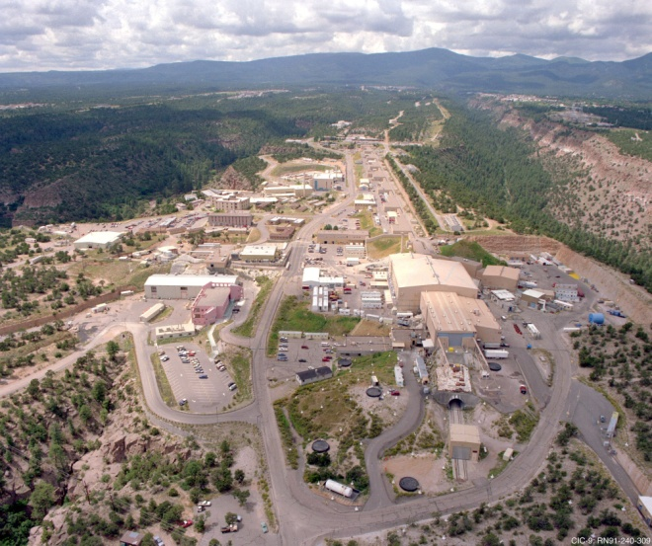
Running since: 1972
Neutron source: Spallation
Number of available instruments: 13 (Lujan Neutron Scattering Center)
Closest urban area: Albuquerque, NM (97 mi)
LANSCE is the major experimental science facility at Los Alamos National Laboratory. At the heart of LANSCE is a powerful linear accelerator that accelerates protons to 84% the speed of light. When these protons strike a target of tungsten metal, neutrons are produced.
“Research conducted at LANSCE helps to maintain the nation’s nuclear deterrent, counter the spread of weapons of mass destruction and lays the foundation for many of the products we use in our daily lives by supporting materials sciences and technology.”

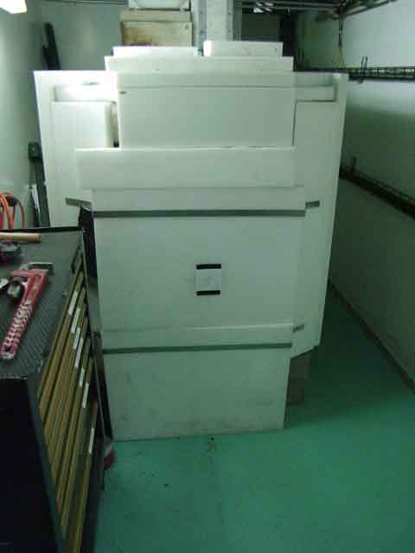
Beam stopper for the Surface Profile Analysis Reflectometer (SPEAR) at the Lujan Center
----------------------------------------------------
NIST Center for Neutron Research (NCNR) @ National Institute of Standards and Technology
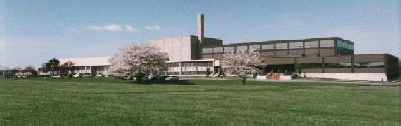
Running since: 1970’s
Neutron source: Nuclear Fission
Number of available instruments: 22
Number of instruments currently under construction: 1 (MACS- Multi-Angle Crystal Spectrometer)
Closest urban area: Washington D.C. (26 mi)
The NCNR is a national center for research using thermal and cold neutrons, Many of its instruments rely on intense beams of cold neutrons emanating from an advanced liquid hydrogen moderator.
Among the thermal neutron instruments, a project to modernize the older neutron scattering instruments in the confinement building has been planned to be implemented over the next few years, which includes the installation of new monochromator drums and refurbishing the triple-axis spectrometers.
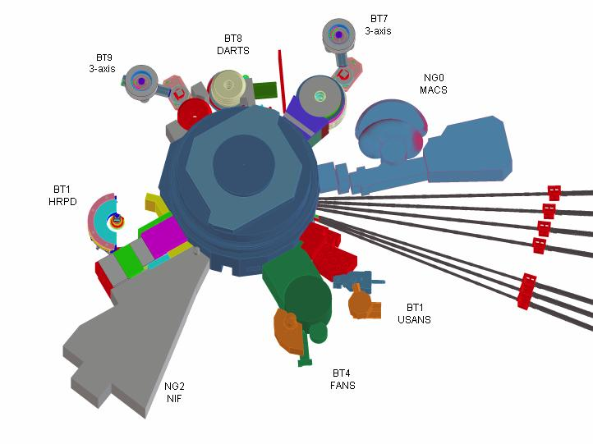
A schematic for the thermal neutron instrumentations in the confinement building at NCNR. Also visible on the right side of the diagram are neutron guides for the cold neutron instruments
Seven neutron guides transport neutrons emerging from the cold source t to the stations in the guide hall. An eighth large neutron beam terminates inside the confinement building, and will provide neutrons for an advanced multi-axis crystal spectrometer (MACS). The neutron guides work by a simple principle, i.e., total external reflection of neutrons from the flat surfaces of a rectangular tube formed by Ni-58-coated glass surfaces. Neutrons which graze the surfaces within a small angle are totally reflected.
----------------------------------------------------
Australia:
Open Pool Australian Lightwater reactor (OPAL) @ Australian Nuclear Science and Technology Organization Lucas Height
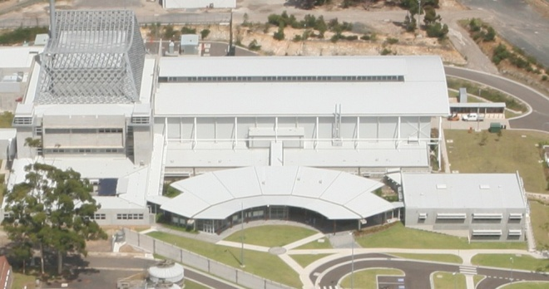
Running since: 2007
Neutron source: Nuclear Fission
Number of available instruments: 6
Number of instruments currently under construction: 7
Closest urban area: Sydney (25 mi)
The institute is the leader of Australia in the use of neutron scattering techniques.
----------------------------------------------------
Canada
National Research Council Canadian Neutron Beam Center (NRC-CNBC) @ Chalk River Laboratories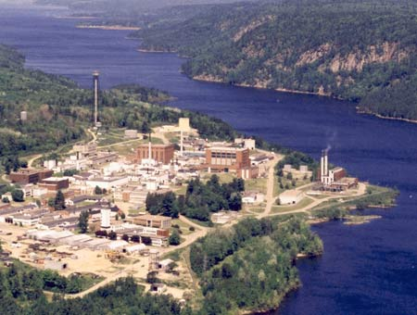
Running since: 1957
Neutron source: Nuclear Fission
Number of available instruments: 7
Closest urban area: Ottawa (115 mi)
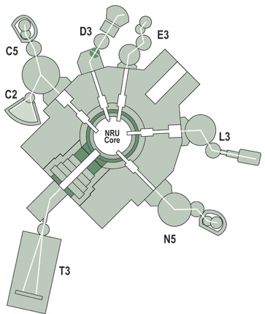
Schematic of neutron instruments at CNBC

----------------------------------------------------

England
ISIS Spallation Source @ Rutherford-Appleton Laboratory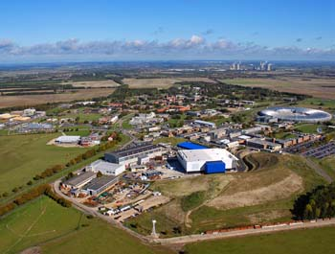
Running since: 1985
Neutron source: Spallation
Number of available instruments: 36
Closest urban area: Oxford (13 mi), London (50 mi)
The name ISIS is not an acronym: it refers to the Ancient Egyptian goddess and the local name for the River Thames. The name was selected for the official opening of the facility in 1985, prior to this it was known as the SNS, or Spallation Neutron Source. The name was considered appropriate as Isis was a goddess who could restore life to the dead, and ISIS made use of equipment previously constructed for the Nimrod and Nina accelerators.
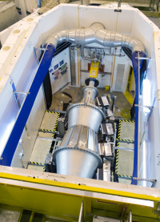
Nimrod is a near and intermediate range order diffractometer designed to provide continuous access to length scales ranging from the interatomic (<1 Å) through to the mesoscopic (>300 Å).
----------------------------------------------------
France
Institut Laue–Langevin (ILL)
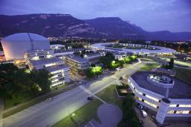
Running since: 1967
Neutron source: Nuclear Fission
Number of available instruments: 46
Closest urban area: Grenoble (in city, 3 mi from city center)
The institute was founded by France and Germany, with the United Kingdom becoming the third major partner in 1973. The institute was named after physicists Max von Laue and Paul Langevin.
----------------------------------------------------
Germany
Forschungsreaktor München II (FRM II) @ Technical University of Garching
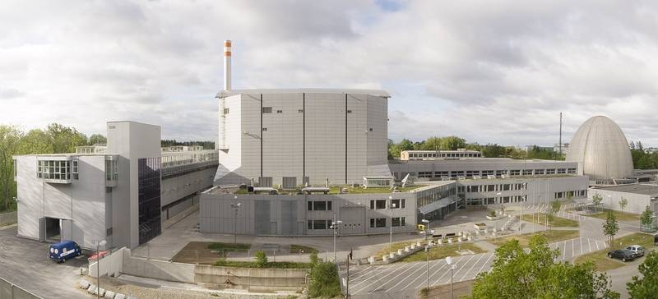

Running since: 2005
Neutron source: Nuclear Fission
Closest urban area: Munich (12mi)
----------------------------------------------------
Switzerland
Swiss Spallation Neutron Source (SINQ) @ Paul Scherrer Institute
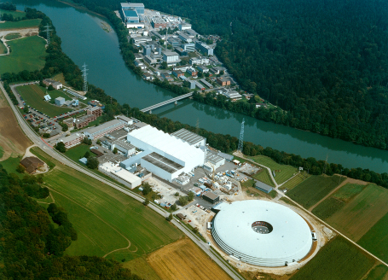
Running since: 1996
Neutron source: Spallation
Number of available instruments: 19
Number of instruments currently under construction: 3
Closest urban area: Zurich (22 mi)
----------------------------------------------------
Sweden
European Spallation Source Scandanavia (ESSS) (project)
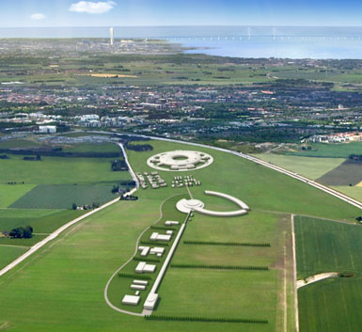
Running since: 2020 (projected)
Neutron source: Spallation
Closest urban area: Copenhagen, Denmark (40 mi)
“The new American Spallation Neutron Source (SNS) is already in operation and the Japanese J-PARC is planned to be finished in 2008. However, still no decision has been made in Europe about where the new European spallation facility, ESS, will be built. If Europe wants to maintain its leading position within neutron research, ESS needs to be finished around 2020, which means that planning must already be started now.”
----------------------------------------------------
Other neutron facilities around the world
Americas
- University of Missouri Research Reactor Center
- Indiana University Cyclotron Facility
Europe
- Leon Brillouin Laboratory, Saclay, France
- Berlin Neutron Scattering Center, Germany
- GKSS Geesthacht, Germany
- Juelich Center for Neutron Science, Germany
- Budapest Neutron Centre, Hungary
- RID, Delft, The Netherlands
- Frank Laboratory of Neutron Physics, Dubna, Russia
- St. Petersburg Neutron Physics Institute, Gatchina, Russia
Asia
- ISSP Neutron Scattering Laboratory, Tokai, Japan
- JAEA Research Reactors, Tokai,Japan
- KENS Neutron Scattering Facility, Tsukuba, Japan
- Hi-Flux Advanced Neutron Application Reactor, Korea
References
http://neutrons.ornl.gov/facilities/SNS/
http://neutrons.ornl.gov/facilities/HFIR/
http://lansce.lanl.gov/
http://www.ncnr.nist.gov/
http://www.ansto.gov.au/research/bragg_institute
http://www.nrc-cnrc.gc.ca/eng/ibp/cnbc.html
http://www.isis.stfc.ac.uk/index.html
http://www.ill.eu/
http://www.frm2.tum.de/en/index.html
http://sinq.web.psi.ch/
http://ess-scandinavia.eu/

