Molecular Conductors

By: Adam Krause

Physics 672

4/17/07

Introduction to Molecular Conductors

In the continuing search for smaller electronic devices, this paper briefly describes the extreme case of molecular conductors and their natural application: molecular electronics. Generally speaking molecular conductors are molecules that carry current. However, as we shall see, these molecules can be functionalized to perform in various ways. Currently there are two types of molecular conductors being studied for the purpose of electrical conductance and molecular electronics application: carbon nanotubes and polyphenylene-based molecules [1]. The latter will be studied in the experiments described below.
This paper will not only show how molecular conductors behave, but also the experimental methods used to measure conductance and current (I(V)) plots. It will also explain the proposed application of polyphenylene-based conductors to create a rectifying diode: one of the building blocks of modern electronics. Finally the application of molecular conductor molecules to produce an electronic memory device is described.

Experimental Measurements of Molecular Conductance

Mechanically Controlled Break-Junction Method: SAM of benzene-1,4-dithiol on Gold Electrodes

The first experimental method to be considered is the mechanically controlled break-junction method. One group used this method to explore the conductance (dI/dV) of the molecule: benzene-1,4-dithiol [2]. In this experiment, a gold wire is immersed in a 1mM THF solution of the benzene-1,4-dithiol molecule. The gold wire is mechanically stretched until it breaks which is where this method gets the name (Fig. 1). The control mechanism is a piezo element which can be precisely controlled. The resulting electrode tips are atomically sharp and covered in a self assembled monolayer (SAM) of the molecule. A voltage, V, is put across the coated electrodes which are then brought close together until an electric current is produced. Fig. 2 shows a close-up drawing of the configuration.
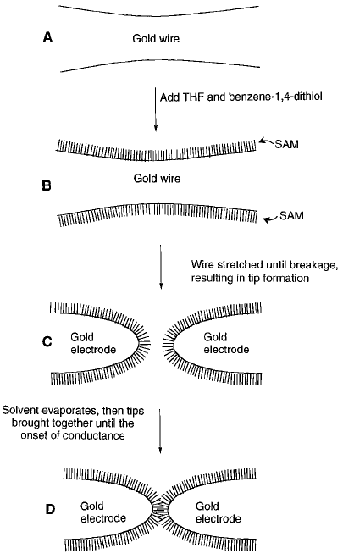
Figure 1: The method of mechanically controlled break-junction is illustrated. A.) The method starts with a narrow gold wire onto which B) a SAM is deposited. C) While still immersed in the SAM solution, using controlled mechanical means the wire is stretched until broken. This produces two SAM coated electrodes D) These electrodes are then brought close enough that a molecular bridge is formed between them. [2]

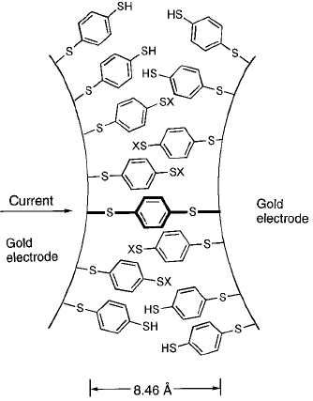

Figure 2: An illustration of benzene-1,4-dithiolate forming a connection between the two electrodes. [2]

Fig. 3 below shows the results of this experiment. Fig. 3A shows the typical current and conductance data versus bias voltage. Notice how there is a 0.7V gap centered on 0V. According to this group the gap behavior was seen for all cases. Fig. 3B shows three offset conductance traces for the purpose of illustrating the reproducibility of the data. The conductance shows a step behavior as the voltage is increased for both positive and negative bias. For the three traces shown in Fig. 3B the first step has a resistance of 22.2, 22.2, and 22.7 megohms respectively. The higher step has lower resistances of 12.5, 13.3, and 14.3 megohms. For one particular measurement the resistance was measured to be approximately half of the typical value (Fig. 3C). This suggests that there were actually two molecules bridging the electrodes instead of one.
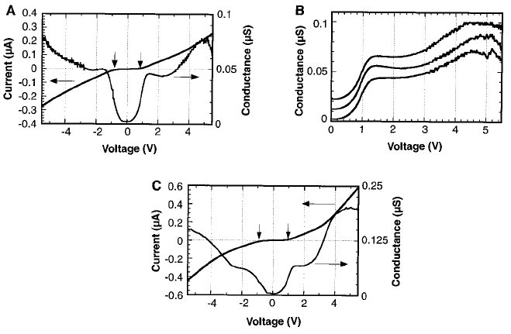
Figure 3: The results of the Reed’s experiment. A) This is a plot of the current and conductance vs. voltage measured during the experiment. B) This is three measurements of the conductance. They are offset for clarity. C) This shows one particular measurement which is about half the maximum resistance measured during the experiments suggesting there are two molecular bridges connecting the electrodes. [2]

Crossed-Wire Method: SAM of OPE on Gold Wire

Kushmerick’s group used a crossed-wire method to measure the electrical properties of a SAM of oligo(phenylene ethnylene) otherwise known as OPE. In this experiment the group aimed to explore the metal-molecule contact and how it affects the metal-molecule-metal electrical properties. Fig. 4A shows the crossed-wire setup. One wire is coated with a SAM of the molecule in question while the uncoated wire is set perpendicular to the other. A magnetic field is applied as shown and a current is sent through the coated wire to induce a Lorentz force which moves the wires closer. To see what kind of connection the molecules are making as a function of Lorentz force, the resistance is measured. Fig 4B shows this data. At low force, the resistance is constant but as the force increases the molecules become distorted and the resistance drops [3]. Also shown in Fig. 4B are the two molecules used in this experiment. One has a thioacetyl group on both terminating ends where the gold will bond, but the other has this group on only one end. In this manner the two different metal-molecule contacts can be compared.
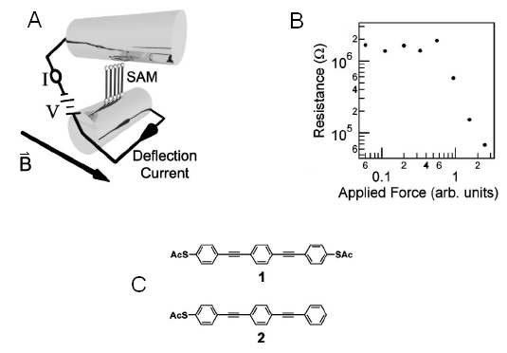
Figure 4: A) Crossed-Wire Method setup. B) Electrical resistance vs. Lorentz Force. After a certain value, the resistance drops corresponding to a deformation of the monolayer molecules. C) Both molecules studied in this experiment are shown. One is symmetric, the other is not. [3]

Fig. 5 shows the results of this experiment. In Fig. 5A the data for the symmetrical molecule (thioacetyl groups on both sides) is shown. The open symbols are for a positive voltage and the closed symbols are for negative voltage. The absolute value of the voltage is shown for comparison between the positive voltage and the negative voltage. Clearly in Fig. 5A the current varies the same for the positive voltage as for the negative voltage. In Fig. 5B the data for the asymmetrical molecule is shown. It is interesting to note that while the current looks as expected for a positive voltage, it is considerably lower for the higher negative voltage levers. This means that the asymmetrical molecule acts as a rectifier allowing current to flow predominantly in one direction. To be specific, the electrons flow more readily from the gold-phenylene side toward the gold-S side. The symmetrical molecule functions as a molecular wire transferring current equally in both directions.
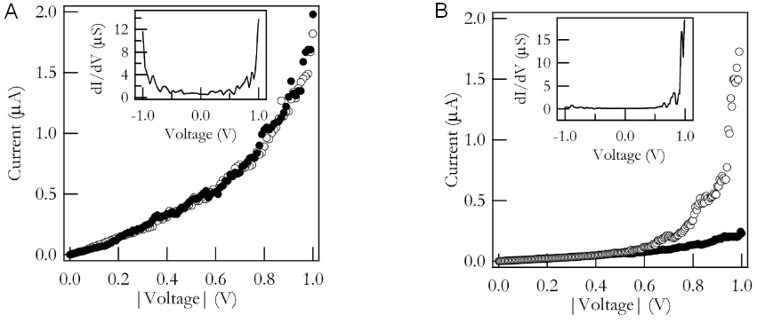
Figure 5: A) Data for symmetrical molecule. It behaves as a typical molecular wire. B) Data for the asymmetrical molecule. It shows a rectifier-like behavior allowing current to flow predominantly in one direction. [3]

STM Break-Junction Method: Bipyridine

The STM break-junction method is different than the other two in that it makes hundreds or thousands of measurements and looks at the results statistically. The way this is done is by using a gold coated scanning tunneling microscope (STM) head, held at a constant bias voltage, and maneuvering it to strike a gold substrate that is covered in a solution of the molecule being studied [5,6]. The tip is then drawn back while the resistance data is taken. A drawing of this setup is shown in Fig. 6.
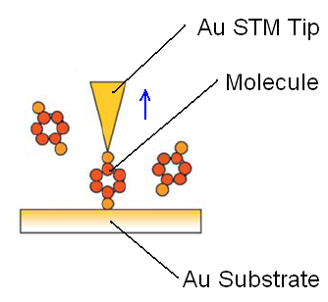
Figure 6: Drawing of the STM break-junction experimental setup. [4]

One group made 1000 measurements of the bipyridine molecule’s conductive properties using this method [5]. The results are shown in Fig. 7.
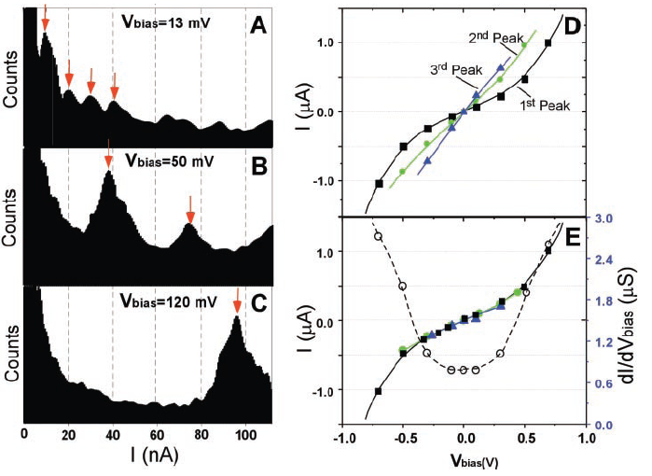
Figure 7: A-C) Histogram of bipyridine for bias voltages of 13mV, 50mV, and 120mV, respectively. As the bias voltage is increased the current peaks increase. D) Varying the bias voltage and recording the current peaks gives this I(V) diagram for the three highest peaks. E) When the data for the second peak is divided by two and the third peak divided by three, the three graphs fall on top of each other. [5]

The histograms in Fig. 7A-7C show the current peaks for three different bias voltages. As the bias is increase, the current peaks shift to the right showing that current increases accordingly. By varying the bias voltages and recording the current histogram peaks, the I(V) graph shown in Fig. 7D are created. The first three peaks are tracked during this process and are shown in the graph. If you divide the second peak by two and the third peak by three the three I(V) curves will fall on top of each other as is shown in Fig. 7E. This effect was also seen for the mechanically controlled break junction in Fig. 3C and is most likely due to two and three molecules bridging the junction respectively.

Current Experimental Applications of Molecular Conductors

We have looked at the experimental side of molecular conductors in which the conductive properties of the molecules were explored. Now we will look at a proposed application: molecular conductor based rectifying diode. This will take us into the new field of molecular electronics. We will then describe how a memory device can be created using molecular conductors.

Rectifying Diode

As was shown above asymmetrical molecular wires can exhibit diode-like behavior. Since a diode is a fundamental electronic component, it would be advantageous to design one made of only a few molecules which takes up significantly less space than their semiconductor counterparts. We will look at the rectifying diode design proposed by Ellenbogen and Love [1] in which polyphenylene-based molecules are used as the conductors. Fig. 8 shows a picture of the diode in question.
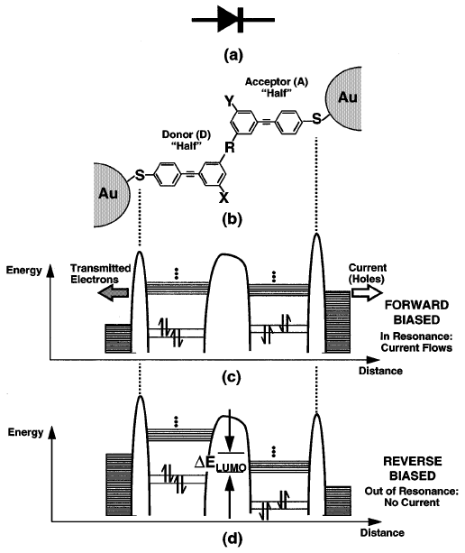
Figure 8. a) Diode symbol showing electron current from right to left. b) This is the Polyphenylene molecule with an electron donating molecular group attached (X), an electron accepting group (Y). The two sided of the diode are attached by a semi-insulating group (R). c) This is an energy diagram when there is a higher voltage on the left than on the right (Forward-Biased) d) This is the energy diagram when there is a higher voltage on the right than on the left (Reverse-Biased). [1]

In Fig. 8b the molecule is shown bridging the gap between two gold electrodes. The molecule is attached to the electrodes using a thiol group (S). The donor side has an extra group attached that readily donates electrons (X). The extra group on the acceptor side (Y) readily accepts electrons. The two halves are connected by a semi-insulating molecule (R).
The energy diagrams for this configuration are shown in Fig. 8c-8d. The closely spaced lines on the outside of both sides of the diagram represent the Highest Occupied Molecular Orbital (HOMO) of the gold electrodes on each side of the diode. The closely spaced lines on the inside of both sided of the diagram represent the Lowest Unoccupied Molecular Orbital (LUMO) of each side of the molecule. The HOMO is analogous to the valence band in semiconductors and the LUMO is analogous to the conduction band. When there is a forward-bias placed across the electrodes (high voltage on the left side) the filled electron orbitals on the right hand side of the diode increase in energy. If the HOMO of the negative electrode is higher in energy than the LUMO of the Acceptor half of the molecule, electrons can flow and occupy the LUMO on the acceptor molecule. If the forward bias voltage is higher enough, the electrons can tunnel through the semi-insulating molecule and occupy the LUMO of the Donor molecule which, due to the bias voltage, is now lowered to the level of the LUMO of the Acceptor molecule. The occupied orbitals on the high voltage electrode have much lower energy than the LUMO energy because the high voltage stripped the upper electrons away. Following this entire path from right to left, the electrons can flow when there is a positive bias voltage.

When there is a reverse-bias, the LUMO of the Donor molecule is higher than the Fermi energy of the left electrode which will not allow electrons to flow to the Donor molecule. In order to raise the Fermi energy enough to cause electron flow, the reverse-bias voltage must be raised much higher than is need to cause conduction in the forward-bias case.

This proposed design behaves like the diodes used today. Since the diode is one of the main building blocks of modern logic circuits, it is conceivable that scientists could build logic gates and even computers out of molecular electronic components like the diode described here. Fig. 9 shows how an AND and OR gate might look built from diodes like the one above.
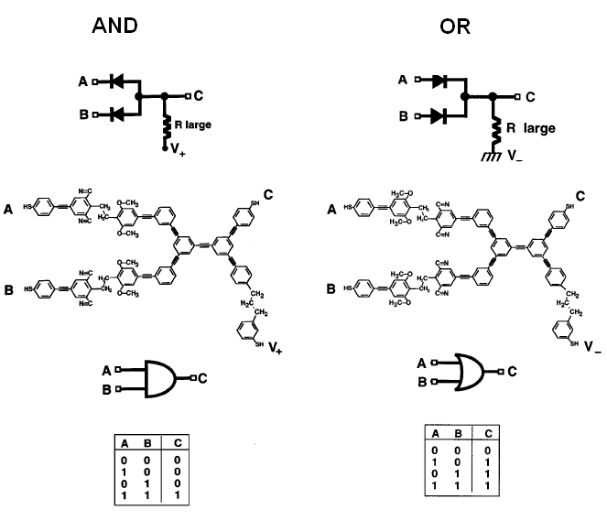
Figure 9: A possible configuration for AND and OR logic gates. [1]

Molecular Memory

The final application of molecular conductors to be discussed here is that of molecular memory. This entails the changing of the conductive state of the molecule depending on the “1” or “0” stored and then reading the state. The work shown was done by Chen et al. [7].

Fig. 10 shows an example of a molecular memory system and the I(V) curves it exhibits. Initially the molecule is in a state “0”. This is shown by the flat trace in the top graph in Fig. 10. This state is read by sweeping a voltage across it for one minute. After the voltage has been applied, subsequent sweeps reveal the molecule to be in the “1” state shown in the top graph of Fig. 10. The molecule’s voltage can continue to be swept and this “1” state persists until the voltage across the molecule is swept negative which returns the molecule to its “0” state.

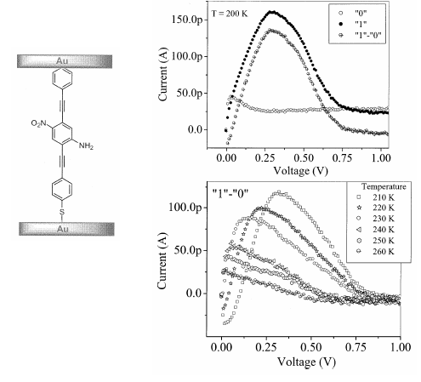
Figure 10: On the left is a molecule used in the research of a molecular memory device. The top graph shows the I(V) curves of the molecule for both the “0” and “1” stored states. Also shown is the difference in these states. The lower graph shows how the difference between the two stored states degrades as temperature increases. [7]

References

1. Ellenbogen, J. C. and J. C. Love, Proceedings of the IEEE, Vol. 88 No. 3, (2000) 386

2. Reed, M. A., et al., Science 278 (1997) 252

3. Kushmerick, J. G., et al., Phys. Rev. Lett 89, (2002) 086802

4. Selzer, Y. and D. L. Allara, Annu. Phys. Rev. Phys. Chem. 57, (2006) 593

5. Xu, B. Q.and N. J. Tao, Science 307, (2003) 1221

6. Xiao, X., et al., Nano. Lett. 4, (2004) 267

7. Chen, J., et al., Ann. N.Y. Acad. Sci. 960, (2002) 69

