Bose Einstein Condensation

Davi Ortega

The establishment of the quantum mechanics in the beginning of the last century brought many new concepts to the physicists. Precisely, general statements such as indistinguishability of particles as electrons, protons, atoms and etc, lead the physicists to new results for ideal gases statistics. In 1925, Einstein [1] published a revolutionary paper proposing interesting results for a Bose gas (gas of boson particles). His conclusions about the degeneracy of the gas for sufficient small temperature carried dramatic consequences to the thermo dynamical properties. This work shows a simplified version of the theory used to predict the Bose-Einstein condensate (BEC) and also discuss some of the interpretations for the results. Furthermore, it presents the pathway follow by several physicists seeking an experimental achievement of pure BEC. Finally the work’s conclusion exemplifies some interesting experimental applications.

Theory

The statistics concerning BEC should start with a brief review about some concepts. The very first one relies on the fact that identical particles in quantum mechanics are indistinguishable. Besides the fact of simplicity the importance of this statement is an immediately split of the quantum gas statistics from classical gas statistics. This because the counting of possible gas states obeys different rules as the chart shows in Figure 1 [2].

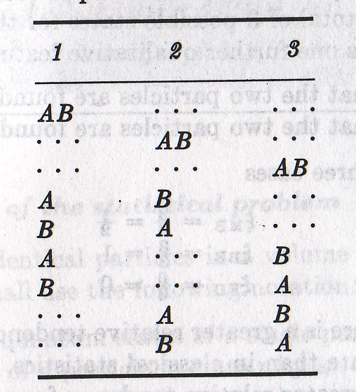
Figure 1: Number of possible states for a classical two particle system.

Another concept is the difference between bosons and fermions in quantum mechanics. Simplifying, Bosons are particles with integer total spin number and has an interesting property that two or more bosons can occupy the same energy state. On the other hand, Fermions are particles with half integer total spin number and they can only occupy an energy state with a single particle. Therefore, one can see that this also alters the way of counting possible energy states of the gas for a Bose gas or a Fermi gas, Figure 2 [2] and consequently modifying their statistics.

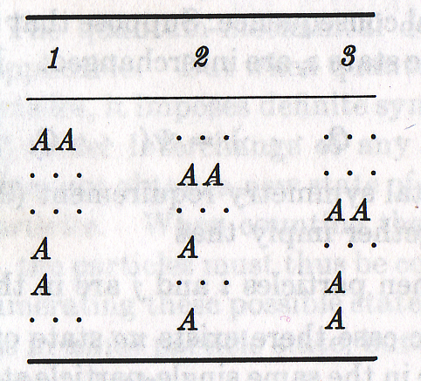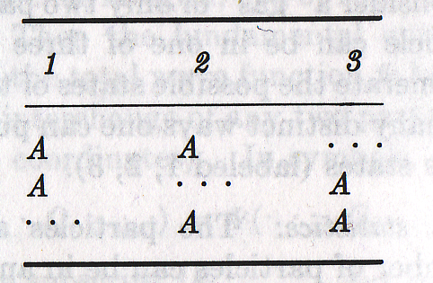
Figure 2: Number of possible states for a two particle quantum gas. On the right supposing the particles are bosons and on the left supposing the particles are fermions.

In fact, the three main statistics of an ideal gas are: Maxwell – Boltzmann Statistics (for classical particles), Fermi – Dirac Statistics (for fermions) and the one this work requires Bose –Einstein Statistics. The most important result of these statistics is the average occupation number of each energy state and we will present this result for Bosons without further explanation for the sake of simplicity. Thus

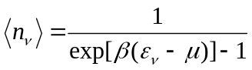 [1]

where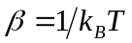, 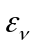 is the energy associated with the state and  is the chemical potential. It is straight forward that for certain numbers of energy and chemical potential the average occupation number tends to infinity.
In posse of this result one can consider an ideal gas of free boson particles in a box with fixed length L and volume V [4]. The energy state for each particle can be calculated (3D infinite well) as:

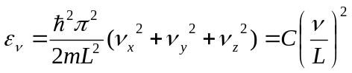 [2]

Now, one can calculate explicitly the average total number of particles:

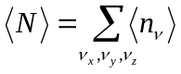 [3]
the evaluation of this expression is omitted here but combining the equations (1), (2) and (3) leads to:

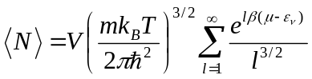 [4]

This expression gets particular interest once determines the relation between temperature and chemical potential. As the temperature decrease from a high value the chemical potential must decrease either since the average number of particle should be constant. However, the chemical potential never cannot assume values higher than the ground state energy and for a certain critical temperature and below the exponential of the expression (4) is 1. Thus:

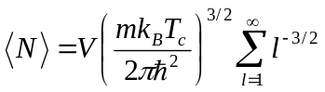 [5]

Einstein was the first one to notice that the particular expression (5) hides some interesting facts. The main point is what would happen if one makes an isothermal compression on the ensemble with that critical temperature. Einstein propose, in order to keep the equation (5) valid, that an number of particles “condenses” to a new quantum state (with no kinetic energy) and the rest of the particles redistribute themselves according to the statistics described here[1]. In other words, Einstein claims that exist a maximum density for each temperature. Once this density is exceeded the excess particles condensates to an unmoving quantum state.
Moreover, using DeBroglie wavelength definition for a particle with thermal energy 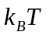 one can find the expression:

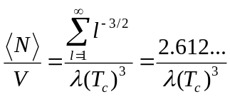 [6]

In other words, this expression shows that the thermal wavelength is of the same order that the density of the ensemble. This means that the wavelength of each particle must overlap each other [4].
However, as said before, just the excess particles condensates. Indeed the remaining particles still obey the statistics in equation (5) and therefore:

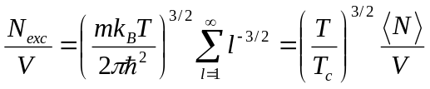 [7]

or

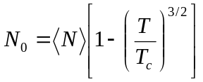 [8]

where 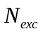is the number of excess particles and 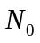is the number of particles that falls to the condensate state. The two above expression are valid just for temperatures below the critical temperature. One also can see that zero temperature means that all the particles goes to the condensate state which is an extreme case of a degenerate Bose gas.
At this point, one must name the “mysterious” quantum state as a Bose-Einstein Condensate. This new state has a significant different behavior than a classical gas. First, the particles in this state doesn’t contribute to the pressure of the gas, also they do not participate in the transfer heat. Another consideration is the viscosity of such substance. As the critical temperature is achieved, superfluidity phenomena can be observed and the viscosity drops for about a million times. Interesting consequences of this fact could be experimentally observed in liquid Helium [5] which deserves the physics nobel prize of 1996.
A last point should be make before move on to the pathway followed by the experimentalists in order to find the BEC in gases. The theory presented here assumes non-interacting particles. However, the particles in such media does interact and therefore the Schrödinger equation of the particles changes dramatically with a non-linear additional term, the famous “Gross-Pitaeviski equation”.

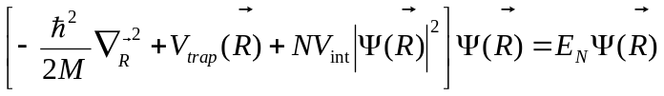 [7]

where the potential of interaction is included multiplying the non-linear term. This coefficient is associated with the strength of the mean field interaction between the atoms: 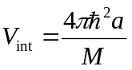, where is the scattering length and is the atomic mass. Now one can see that if 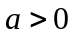the interaction is repulsive the BEC tends to disperse. On the other hand, if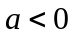 the interaction is attractive the BEC collapses.
The importance of this last theoretical point in this paper is that the major part of theoretical studies in BEC is about solutions for the Gross Pitaeviski equation. Also, as one can see, the conditions to form a BEC is also dependent of the scattering length.
Indeed, this section shows the Bose-Einstein statistics applied to a ensemble of ideal quantum gas. The results of this calculations leads us to find a new state of matter, the condensate, as Einstein propose. This section also shows the Gross – Pitaeviski equation which describes the atoms inside a BEC gas and the study of its solutions is one of the most important theoretical research field in BEC.

Seeking the BEC – The experiments path.

During the 1930s the first observation of the 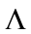 transition of liquid 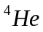 at 2.2K was probably the first time that such matter state was observed experimentally. However, this atom has such strong interaction that less than 9% of the atoms falls to the condensate state. The next attempt was quite straight forward. In middle 70s the Hydrogen atom was completely studied once it is the simplest atom and the equations could be solved explicitly. It seems to be a good choice and many groups tried to condensate Hydrogen for several reasons. However, the formation of a 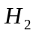 molecule played a major rule that avoid the BEC formation of this atom until 1998 [4].
Conversely, another research area was growing fast. The results obtained by the physicists working with cold atomic samples trapped in magneto-optical traps were promising. However, the requirements, equation (6), to achieve BEC was quite difficult to obtain for a low density atomic vapor. Placing some numbers, one would need two orders of magnitude more density than the typical density number obtained by a typical 3D magneto optical trap (MOT). Also at these typical densities obtained one should have the sample in about some few nK in temperature to be able to see the condensate. This temperature was by far out of range of the typical MOTs. At this point, starts to be clear that some additional cooling mechanism should be applied in the MOT samples in order to reach lower temperature and higher density.
Certainly, after years of research the scientist from JILA was able to report the first BEC in atomic vapor in 1995. The pathway to achieve the BEC is a marathon. First, one trap and cools the atoms to a few mK using and regular MOT. Then a polarization gradient optical molasses cools the atoms to a temperature at the same order of the critical temperature. The next stage is a purely magnetic trap. In this stage the lasers are shut off in order to avoid disturbance by photons absorptions. Finally an evaporative cooling using RF extracts the most warms atoms and let the cold ones which remains at the trap rethermalize. This last cooling stage tends to loose several atoms during the process, however the gain in temperature is enough to reach the BEC.
The first BEC reported was in Rb [6] and the measurement was made by destructive ballistic technique. The results are shown on the Figure 3, famous after the nobel prize in 2001. In this picture the x and y axis are space coordinates and the z axis is brightness of the picture (directly related to density of the cloud). Here one can see the BEC formation as the temperature goes down once the Gaussian profile of the regular gas changes to pronounced peak clearly a BEC signature.

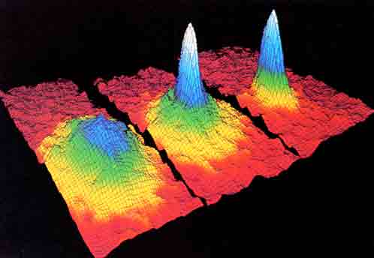
Figure 3: Shows the evolution of the a) trapped atoms with temperature much higher than the critical temperature, b) temperature at the same order as the critical temperature and finally c) the pronounced peak of the BEC.

Finally, in this section, we show how the early laboratories made the first BEC. Such a complicated experiment involves several concepts and for the sake of convenience is not explained fully in this paper. The experimental procedures had to be so carefully executed that just in 1997 successful reports of BEC starts to be published. Several improvements in the detection schemes also provide more useful data lately and nowadays BEC is an entire research field by itself. Also, nowadays the techniques to produce BECs have been improved. All optical BEC provided technology to extend the atoms in this matter state from the alkali atoms, since the needed of atomic hyperfine structure is needed to apply evaporative cooling using RF.
Applications and Conclusion:

There are several applications of BEC in actual research. This paper will select some of them at will to talk briefly. One interesting application is the matter waves produced coherently by BEC, or atom laser. The beam is made of atomic waves and has special interest in any experiment that uses an atomic beam since the coherency can improve the precision of some measurements such as in atomic clocks. Another interesting experiment is the production of a vortex lattices in the BEC media [7]. This is especially interesting since the superfluidity property do not allow a vortex formation when the media is “stirring up”. However, when one spin the trap of a dilute gas BEC the formation of several “local” vortices appear. The combination of this technique with a optical lattice formation tends to be promising in order to study also superconductors.
In conclusion, this paper shows a simple approach in order to apply Bose – Einstein Statistics to an ideal quantum gas. Also recover the main concepts of the theory and the interpretations that predicted the condensate state. Then, it shows a briefly story about the BEC and finally appoints two interest experiments born from the BEC field. Finally, the references [8], [9] and [10] provide some review articles about the subject as well.

Reference:

[1] – Einstein A., Sitzungsberichte (Berlin) 1 (1925) 3-14. < http://www.physik.uni-oldenburg.de/condmat/TeachingSP/SP.html>
[2] – Reif F., “Fundamentals of Statistical and Thermal Physics,” McGraw-Hill, 1985.
[3] – Harald F. “Theoretical Atomic Physics,” Springer, 2006.
[4] – Metcalf H. J., van der Straten P., “Laser Cooling and Traping,” Springer, 1999.
[5] - David M. Lee, Douglas D. Osheroff and Robert C. Richardson, Phys. Rev. Lett. 28, 885 - 888 (1972)
[6] - M. H. Anderson, J. R. Ensher, M. R. Matthews, C. E. Wieman, and E. A. Cornell, Science, 269, 198-201 (1995).
[7]- S. Tung, V. Schweikhard and E.A. Cornell. 2006. Observation of vortex pinning in Bose-Einstein condensates. Physical Review Letters. 97, 240402 (2006)
[8] - E. A. Cornell and C. E. Wieman, Nobel Lecture: Bose-Einstein condensation in a dilute gas, the first 70 years and some recent experiments, Rev. Mod. Phys. 74, 875 - 893 (2002).
[9] – W. Ketterle, Nobel lecture: When atoms behave as waves: Bose-Einstein condensation and the atom laser, Rev. Mod. Phys. 74, 1131 - 1151 (2002).
[10] - < http://www.colorado.edu/physics/2000/bec/>

